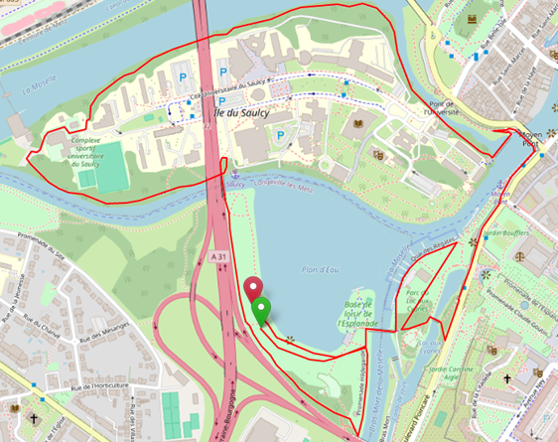
5KM
ARRIVEE
DEPART

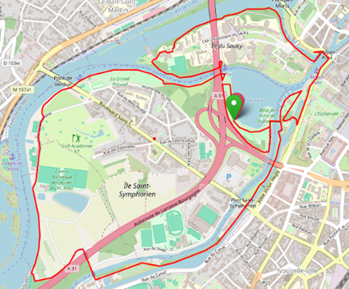
10KM
ARRIVEE
DEPART

